Twitter Stock Market Analysis using Python

1. Introduction
Stock market analysis plays a crucial role in understanding the performance and behavior of publicly traded companies. This project focuses on analyzing Twitter's historical stock market data using Python. The objective is to study price movements, trading volume, and volatility trends to gain meaningful insights into the stock's performance.

2. Problem Statement
The main objective of this project is to analyze Twitter stock data to understand trends in stock prices, price fluctuations, and trading volume over time. The analysis aims to help investors and analysts make informed decisions based on historical stock behavior.

3. Methodology
The project follows a structured methodology starting with data loading and preprocessing. Missing values were identified and removed to ensure data quality. Exploratory Data Analysis (EDA) was then performed using statistical summaries and visualizations to analyze stock price trends, volatility, and trading activity.
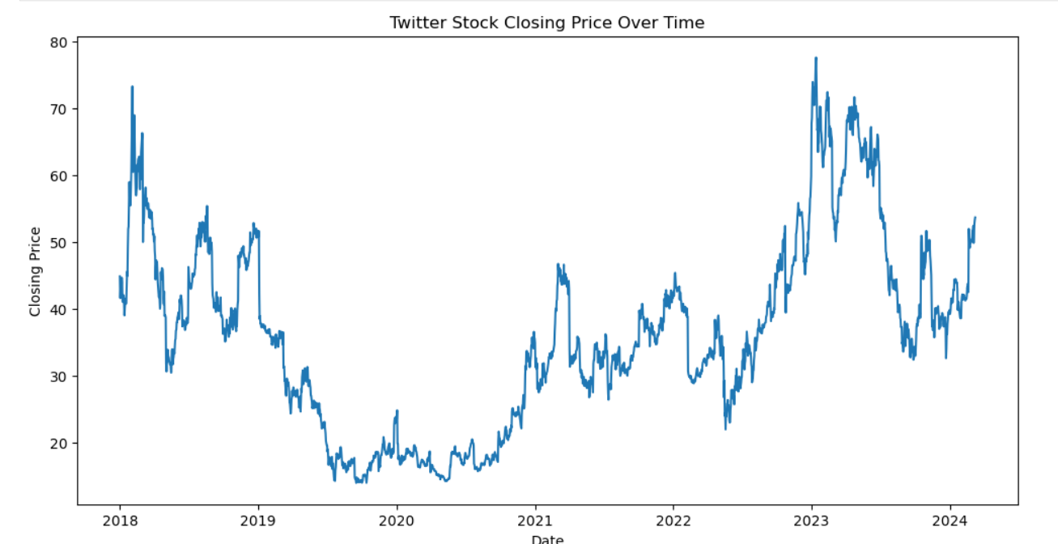

4. Requirement Analysis
Tools and technologies used in this project include Python programming language and Jupyter Notebook. Python libraries such as pandas were used for data manipulation, while matplotlib was used for data visualization. The dataset used consists of historical Twitter stock prices containing Date, Open, High, Low, Close, Adjusted Close, and Volume.
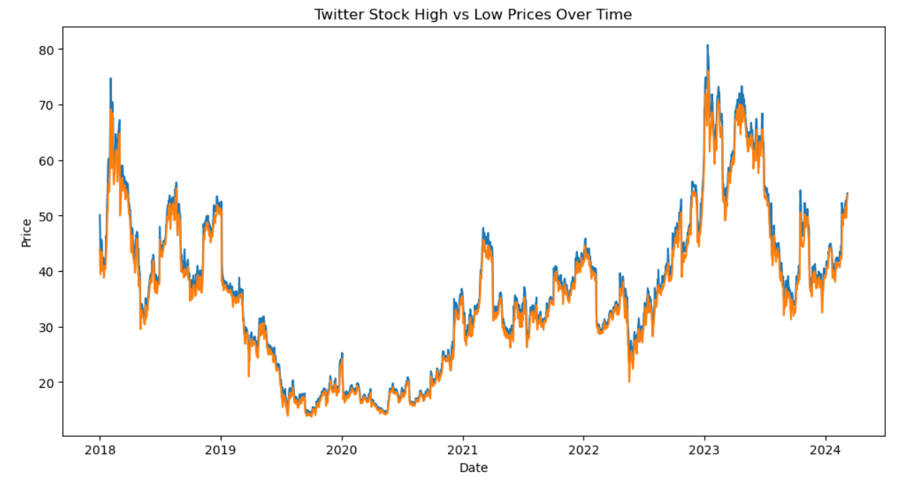

5. Dataset Description
The dataset contains daily stock market data of Twitter. The Date column represents the trading date. Open, High, Low, and Close represent daily stock prices. Adjusted Close reflects price adjustments, while Volume represents the number of shares traded on each day.

6. Data Cleaning and Preprocessing
The dataset was examined for missing values across all columns. A small number of null values were identified in price and volume columns. These rows were removed using the dropna() method to ensure a clean dataset for accurate analysis.

7. Exploratory Data Analysis and Visualization
Several visualizations were created to analyze Twitter stock performance. A line chart was used to visualize the closing price trend over time. High vs Low price charts highlighted daily volatility, while volume charts represented investor participation and market activity.

8. Insights and Findings
The analysis revealed noticeable fluctuations in Twitter's stock prices, indicating periods of volatility. Certain time periods showed increased trading volume, suggesting strong investor interest possibly driven by market news. The gap between high and low prices varied across time, highlighting changing market stability.
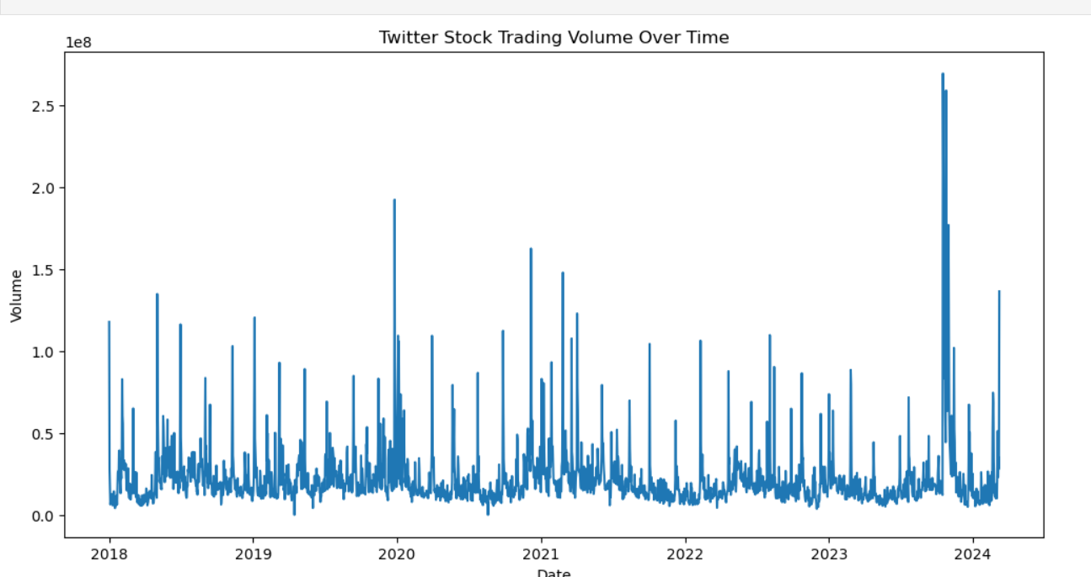

9. Limitations and Future Scope
The analysis is limited to historical price and volume data and does not consider external factors such as financial statements, market sentiment, or global economic conditions. In the future, the project can be extended by incorporating machine learning models, sentiment analysis from social media, and comparative analysis with other technology stocks.

10. Conclusion
This project successfully demonstrates how Python can be used for stock market data analysis. By cleaning the data, performing exploratory analysis, and visualizing trends, valuable insights into Twitter's stock performance were obtained. The findings can assist investors and analysts in understanding historical behavior and making informed decisions.

